GUIDES

**Xampp Installation**

-Before running the program first you need to download and install Xampp since I am using MySQL database

-Run Xampp Control Panel as Administrator

-install apache service if it is not installed then click start

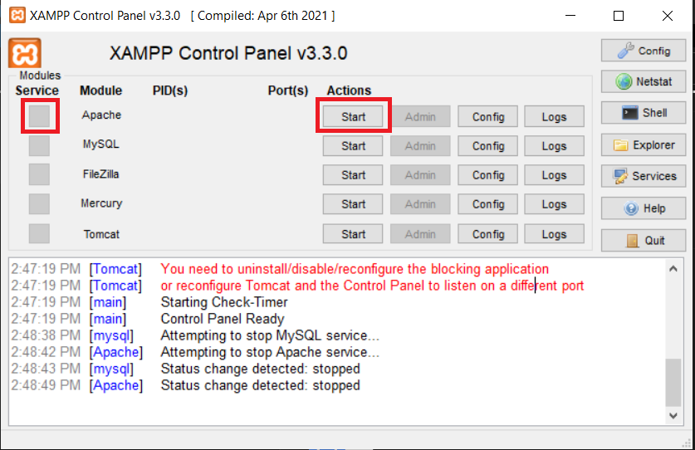

-install MySQL service if it is not installed then click start

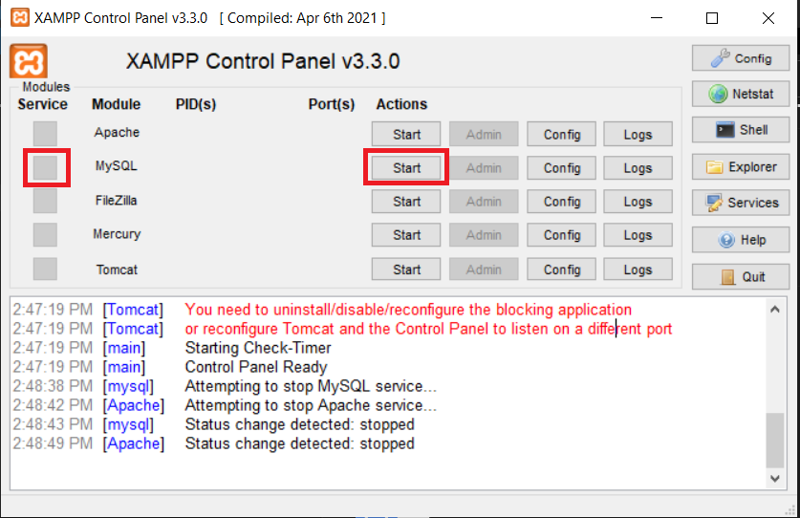

-Open your Localhost database by clicking the admin button of MySQL

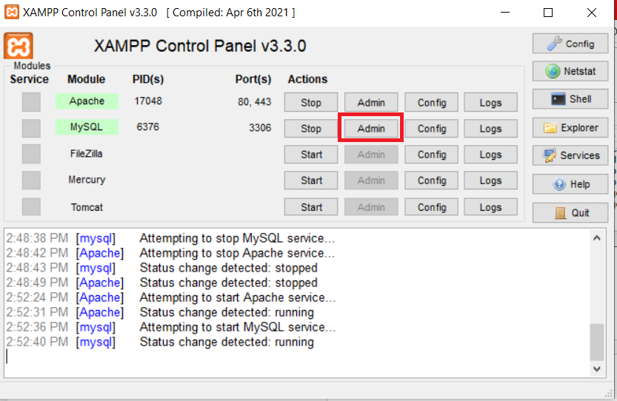

**Database**

-create a database name youtube_db

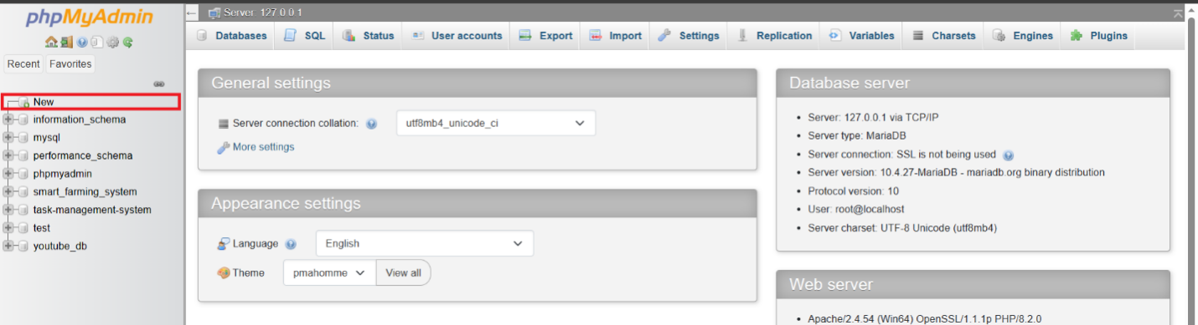

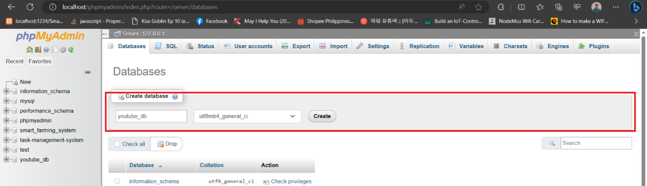

-after creating a database, open the database in the right side by clicking it and you need to import the database (database is lcoated inside the folder also named "youtube_db.sql"

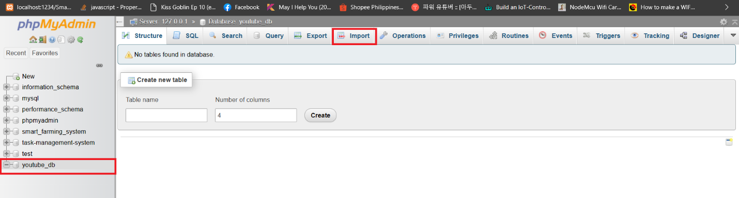

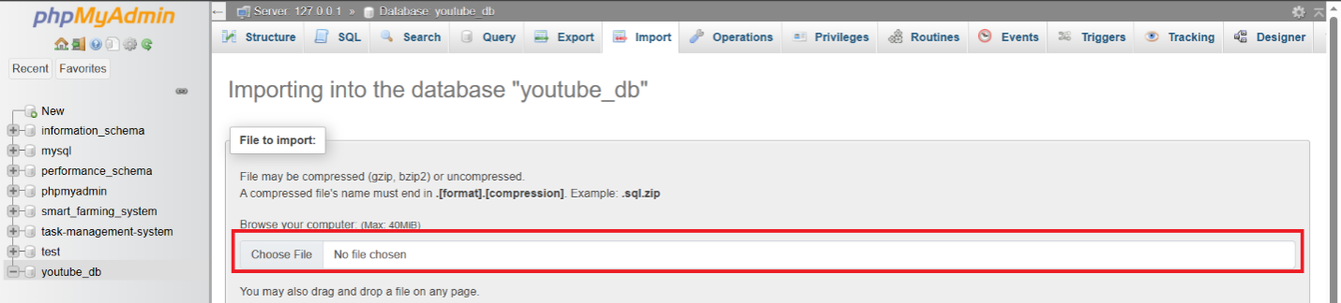

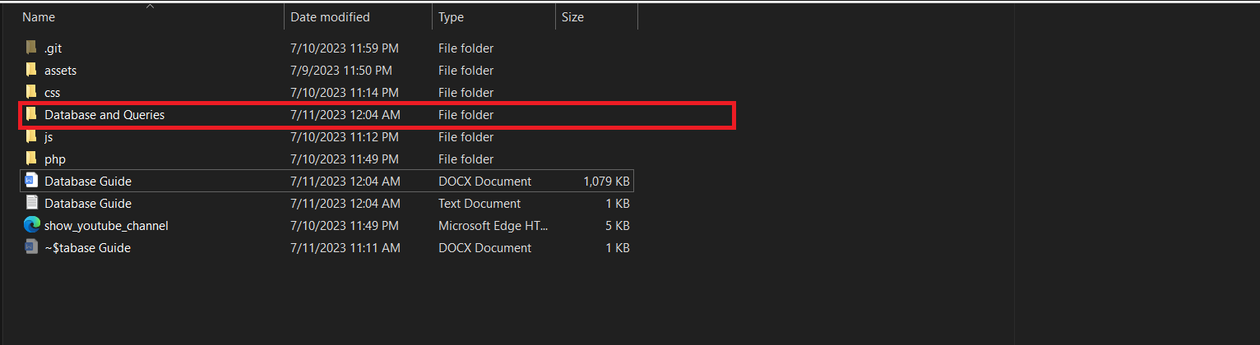

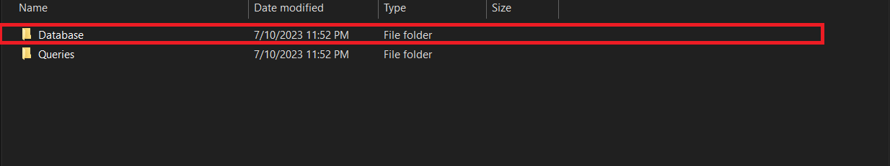

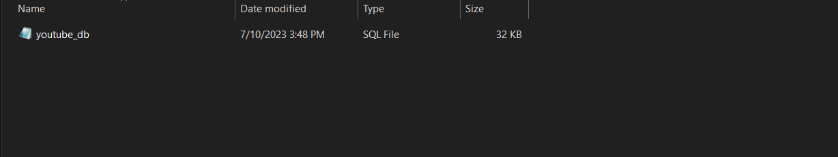

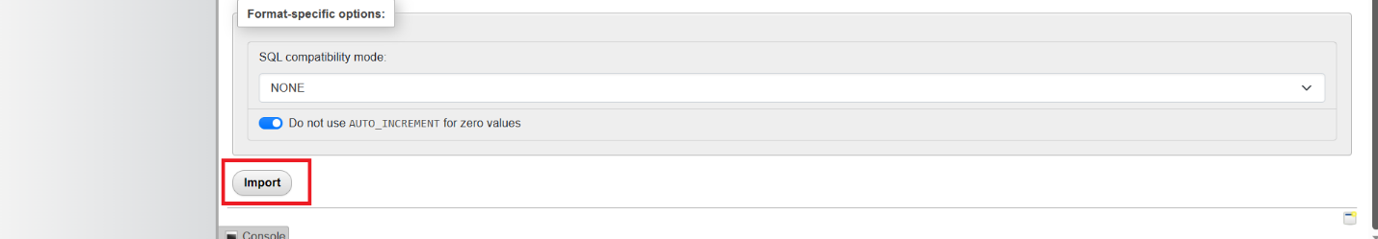

**Xampp Directory**

-Go to xampp directory by going into the directory where did you install your xampp and following the file path “xampp -> htdocs”.

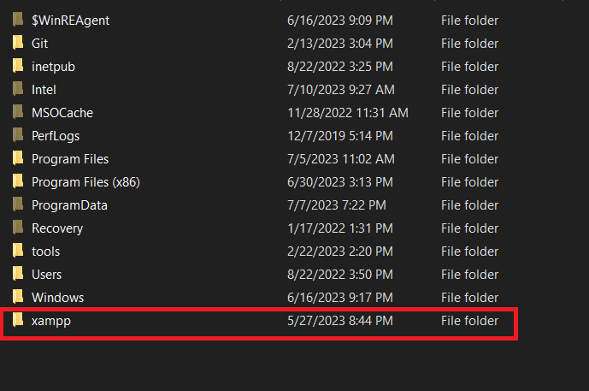

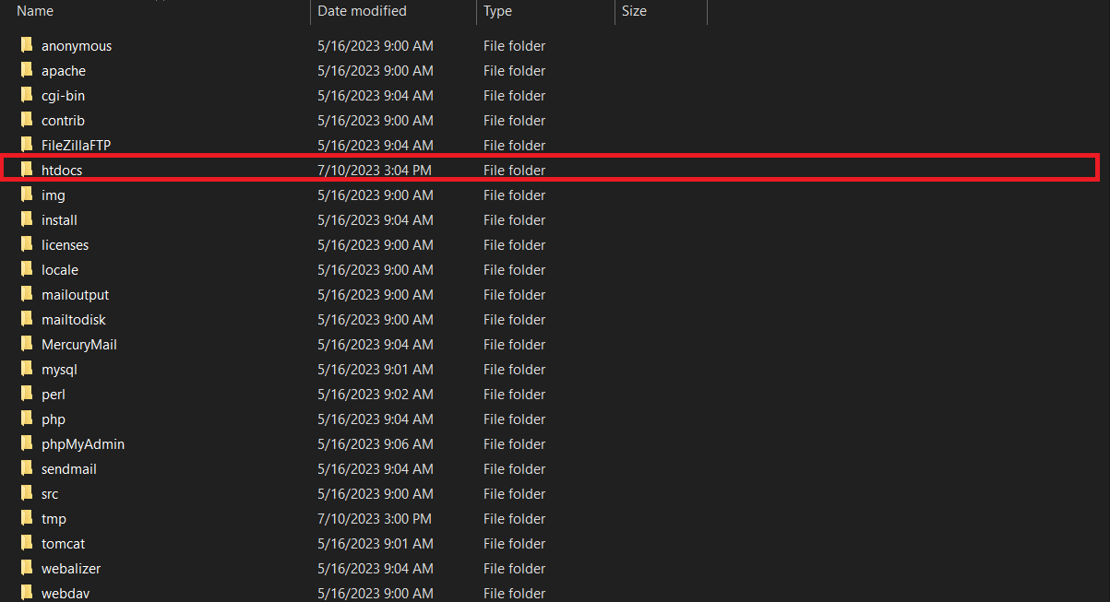

-Inside the htdocs folder, create a folder named “youtube” and place all the files that you have downloaded into that folder.

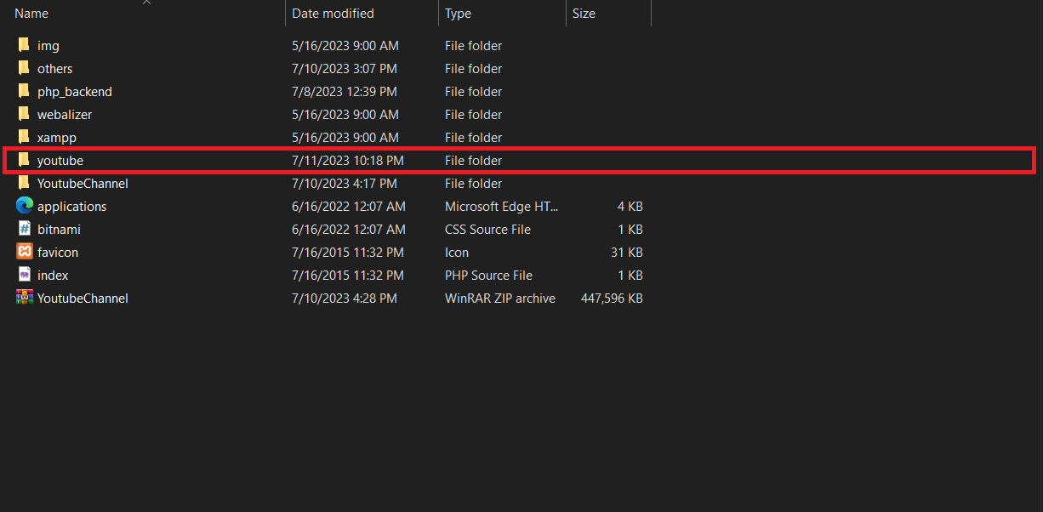

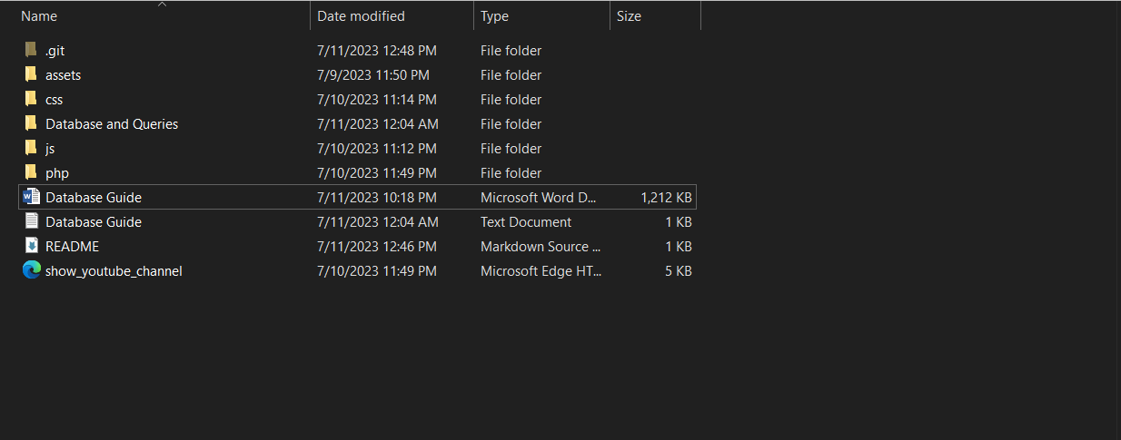

-Aftero doing that, try to run the program by opening the show_youtube_channel.html into your browser.